
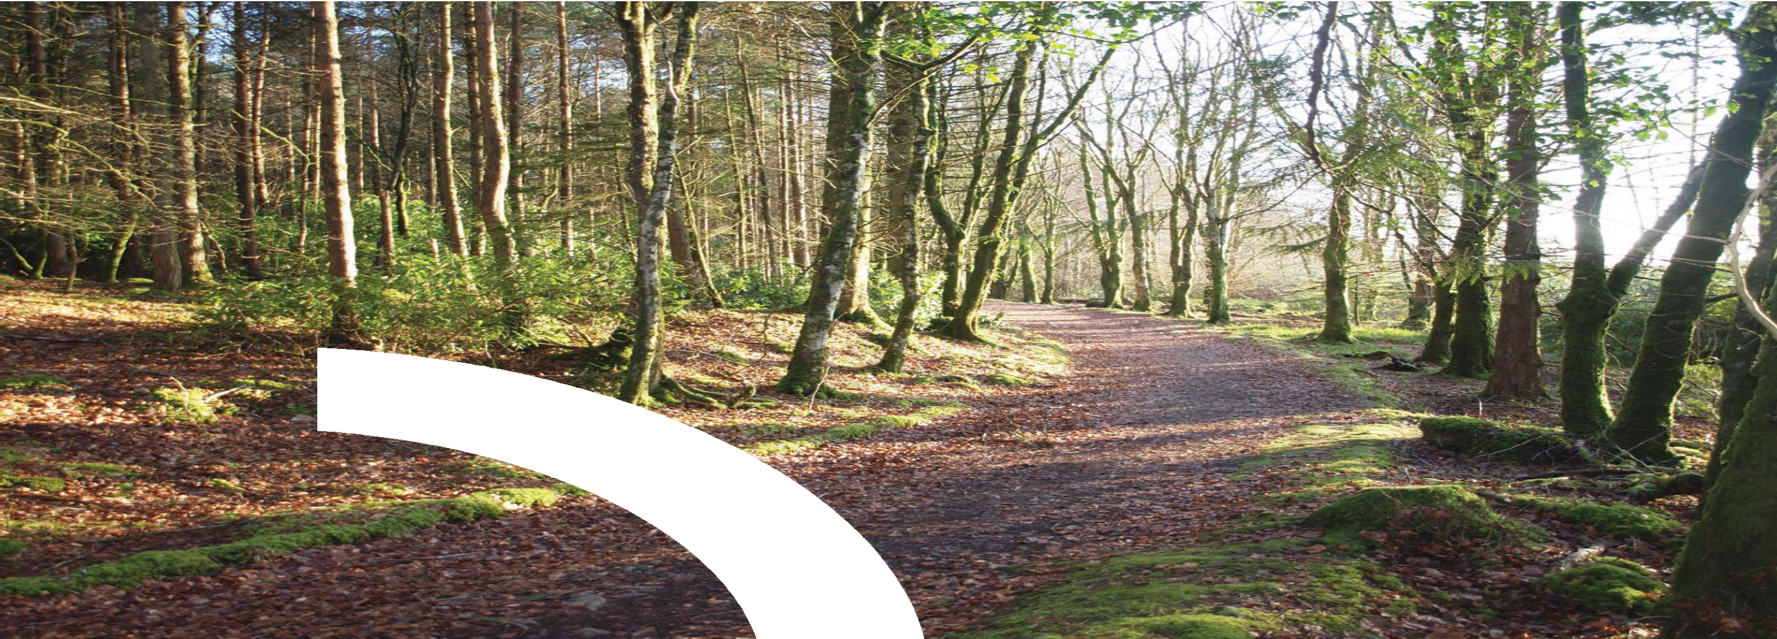
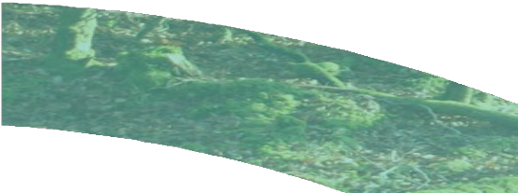






Trail Management Plan

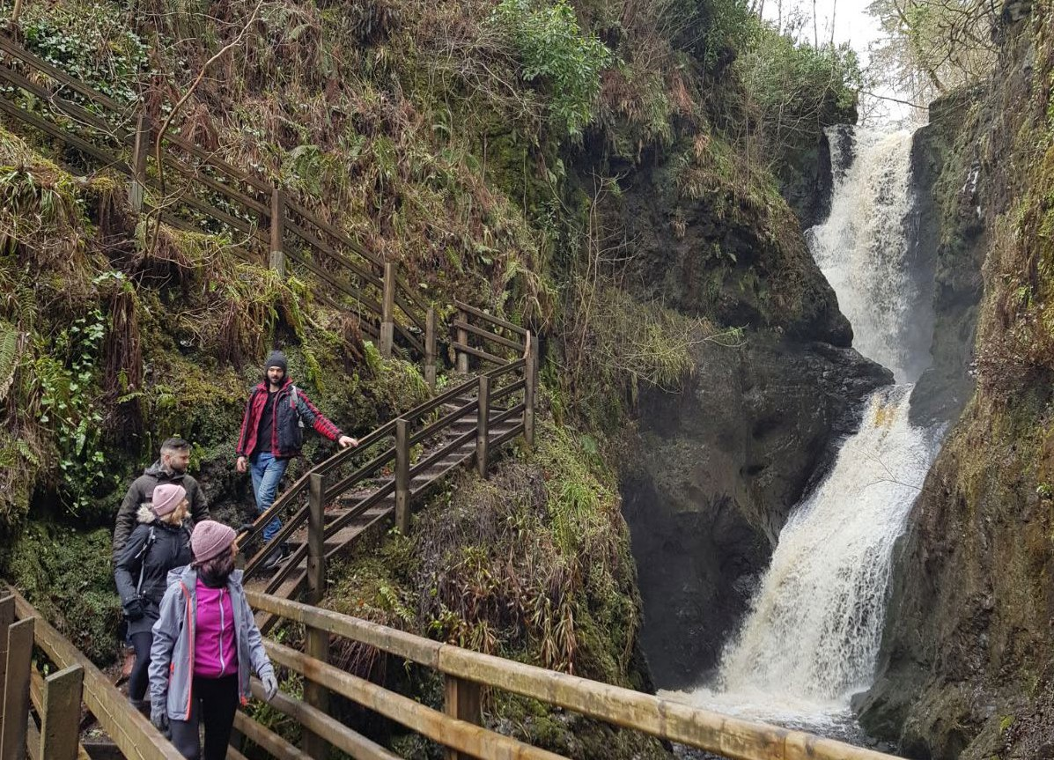

Trail Details

Trail Name(s):
County:
Grade(s):
Length(s):
Plan Period:
Trail Management Details:

Trail Management Organisation / Committee (TMO):
Primary Contact Person:
Phone Number:
Email Address:
Number of People Involved in the TMO:
TMO Meeting Frequency (to discuss the trail(s)):
Are Records or Minutes of Meetings Kept:
Trail Inspection & Maintenance Details:

Inspections Carried Out By:
Maintenance Carried Out By:
Any Other Bodies Involved & Details:

Risk Assessment

Public Safety Risk Assessment
Location: TRAIL or TRAIL NETWORK NAME |  | Date Completed: DATE | Review Date: DATE (at least annually)
Activities taking place at this location: WALKING/CYCLING/etc. |  | Completed By: NAME
Risk Level Matrix
Likelihood/Consequence | Slightly Harmful (SH) | Harmful (H) | Extremely Harmful (EH)
Unlikely (U) | Trivial Risk (TR) | Acceptable Risk (AR) | Moderate Risk (MR)
Likely (L) | Acceptable Risk (AR) | Moderate Risk (MR) | Substantial Risk (SR)
Highly Likely (HL) | Moderate Risk (MR) | Substantial Risk (SR) | Intolerable Risk (IR)

Nature of hazard | Location | Who might be harmed? | How might they be harmed? | Initial Risk Level  Before control measures |  |  | Control Measures | Residual Risk Level  After control measures introduced |  |  | Additional Control Measures  Identified through implementation, monitoring, review
Likelihood – Consequence – Risk Level |  |  |  | L | C | RL |  | L | C | RL
Constructed environment  e.g. car parks, trail surfaces, slipways etc. |  | Trail users General public Inspection and maintenance volunteers | Slips, trips, and falls causing injury.
Getting lost |  | Trail users Inspection and maintenance staff | Physical or emotion distress.
Livestock |  | Inspection and maintenance staff  Trail users General public | Emotional distress, physical harm or death.
Visitor conflict |  | Trail users General public Inspection and maintenance volunteers | Physical or emotion distress.
Maintenance operations  e.g. use of machinery etc. |  | Trail users General public Inspection and maintenance volunteers | Health, safety, and welfare.
Litter and dog waste |  | Trail users General public Inspection and maintenance volunteers Wildlife | Health, safety, and welfare.

Nature of hazard | Location | Who might be harmed? | How might they be harmed? | Initial Risk Level  Before control measures |  |  | Control Measures | Residual Risk Level  After control measures introduced |  |  | Additional Control Measures  Identified through implementation, monitoring, review
Likelihood – Consequence – Risk Level |  |  |  | L | C | RL |  | L | C | RL
Fire |  | Trail users General public Inspection and maintenance volunteers Wildlife | Smoke inhalation, burns, damage to environment.
Flooding and fast flowing water |  | Trail users Inspection and maintenance staff | Damage to property, entrapment, and drowning.
Natural Environment e.g. hazards arising from natural terrain & conditions |  | Trail users General public Inspection and maintenance volunteers | Slips, trips, and falls causing injury.  Emotional distress.
Weather Conditions e.g. changing or extreme weather |  | Trail users General public Inspection and maintenance volunteers | Emotional distress, physical harm or death.
Wildlife e.g. wild animals or insects |  | Trail users General public Inspection and maintenance volunteers | Physical or emotion distress.
Health & Wellbeing  e.g. Dehydration, heatstroke, hypothermia, fatigue, overexertion etc. |  | Trail users General public Inspection and maintenance volunteer. | Emotional distress, physical harm or death.

Nature of hazard | Location | Who might be harmed? | How might they be harmed? | Initial Risk Level  Before control measures |  |  | Control Measures | Residual Risk Level  After control measures introduced |  |  | Additional Control Measures  Identified through implementation, monitoring, review
Likelihood – Consequence – Risk Level |  |  |  | L | C | RL |  | L | C | RL
Accessibility & Inclusion e.g. hazards or barriers for people with disabilities or limited mobility |  | Trail users General public Inspection and maintenance volunteers | Physical or emotion distress
Emergency Response e.g. areas with poor mobile signal, lack of emergency access routes, no clear evacuation procedures,  no contact information or help points |  | Trail users General public Inspection and maintenance volunteers. | Emotional distress, physical harm or death.

Trail Monitoring Tool
Monitoring refers to checking the trail regularly to ensure that everything is order and to identify any unforeseen issues, for example, electric fence warning signs missing, fallen waymarkers, damage to stiles or other trail furniture etc.

The appropriate frequency of monitoring depends on the trail’s characteristics. This section will help to estimate how often the trail should be monitored and determine a monitoring schedule.

It is the responsibility of the Trail Management Organisation to ensure monitoring is carried out and written records of the monitoring is maintained. The Trail Activity Log may be used to record details of monitoring activity.

- Assign a score for each of the parameters listed below to determine a total. In the ‘Potential for Issues / Seasonal Change’ section, consider factors like storm damage, flooding, high-use events such as walking festivals etc.

Parameter | 1 | 2 | 3 | Score
Usage Level | Low | Medium | High
Grade & User Profile | Difficult Grade Experienced Users | Medium Grade Moderate Users | Easy Grade Novice Users
Potential for Issues / | Low | Medium | High
Amount of Trail Furniture, Signs etc. | Low | Medium | High
Total Score:

- Based on the Total Score, determine a guideline Monitoring frequency from the table below:
Months
Comments (if necessary)

Total Score | Guideline Inspection Frequency
4-5 | Annually
6-7 | Bi-Annually
8-9 | Quarterly
10-11 | Monthly
12 | Weekly - Fortnightly

- Based on the Guideline Frequency, determine an annual Monitoring Schedule:

Trail Inspections – Potential Issues

Map Board
  - Dirty/Illegible
  - Loose
  - Damaged

Waymarking
  - Missing
  - Misaligned/Confusing
  - Hidden/Obscured/Dirty
  - Inconsistent (Colour/Name/Symbol)
  - Loose/Leaning
  - Diversion without Waymarking

Missing Signage
  - Busy Road (Motorists & Walkers)
  - Bulls/Livestock
  - Electric Fencing across/beside Trail

Trail Furniture / Structures
  - Damaged
  - Loose
  - Slippery Surface

Vegetation & Litter
  - Vegetation Blocking Route/ Too Long
  - Vegetation Blocking Stiles/Gates etc
  - Litter/Dumping

Trail Surface / Water Management
  - Trail Obstructed/Impassable
  - Muddy/Boggy
  - Flooded/ Waterlogged
  - Slippery/Loose
  - Difficult to Walk for more than 5m
  - Drains Blocked/Overflowing
  - Broken Drains/ Waterbars etc

Fencing (Across/Beside Trail)
  - Exposed Barbed Wire
  - Exposed Electric Fence
  - Broken/Damaged Fence

Potential Safety Issues
  - Barbed Wire/Sharp Objects
  - Hidden Dangers e.g. Holes/ Wires/Drops
  - Damaged/Rotting Trail Furniture
  - Slippery Surfaces
  - Dangerous River Crossings

Trail Maintenance Planner
Maintenance usually refers to regular, known, preventative tasks required to keep the trail in a good and sustainable condition.

Examples include clearing vegetation, clearing out drains, cleaning waymarking and picking-up litter. These tasks need to be identified and planned in advance. You should also identify which organisation will be carrying out the tasks (e.g., the Trails Management Organisation, RSS workers, or another organisation such as Coillte etc).

Code | Task | Applicable (Yes/No) | Frequency (Weekly/Monthly/ Annually etc) | When (Months/ Year) | Location (Whole trail or, if  particular section/s, specify where) | Who
Regular / predictable on-going tasks (seasonal / annual)
01 | Clean information board and other waymarking & signage at trailhead/s
02 | Clean all waymarking throughout trail/s
03 | Clean all signage throughout trail/s (including walkers on road signs)
04 | Pick up litter
05 | Cut-back all encroaching vegetation (branches/briars etc), as necessary, to ensure that the trail is maintained a minimum of 1 metre in width (where possible)
06 | Mow / strim vegetation on the surface of the trail, as necessary, to enable ease of passage for trail users
07 | Cut-back vegetation at stiles, gates and other passing places
08 | Cut-back vegetation / strim around waymarking & signage to ensure it is visible

09 | Remove leaves etc from stiles, bog bridges and boardwalks etc to ensure the trail surface is not slippery
10 | Clear-out all open drains of debris
11 | Clear-out all buried drainage pipes of debris
12 | Surface remediation (filling of pot holes etc) depending on trail grade
13 | Other (specify)
Emerging tasks / tasks identified during monitoring
14 | Repair / replace protective tubing on electric wire that crosses the trail
15 | Re-attach / replace new hazards signs on electric wire, crossing or adjacent to the trail
16 | Repair / replace slip-resistant surfaces on trail furniture (stiles, bog bridges etc)
17 | Repair / replace trail furniture (stiles, bog bridges, handrails etc), particularly that of timber construction
18 | Repair / replace fencing separating the trail from potential hazards (livestock, drops etc)
19 | Other (specify)
Long-term tasks*
20 | (specify)

* These tasks will primarily relate to structures on the trail that are intended to last a particular length of time, after which replacement may be necessary. It is good to recognise these long-term maintenance requirements within the Plan, so that they can be prepared for and, where necessary, funding obtained for them in advance. One such example might be a long section of boardwalk which it is planned to replace a specified number of years after it is installed.

Trail Activity Calendar
Create a monthly ‘to do’ list for each month of the year using the Monitoring Schedule established above and the predictable on-going tasks identified in the Routine Maintenance Planner. For maintenance tasks the Code may be used (rather than writing out the full task).

Once complete, each task should be logged in the Trail Activity Log.

Month | Monitoring and / or maintenance tasks required | Who
January | Monitoring and / or maintenance tasks required | Who
February
March
April
May
June
July
August
September
October
November
December

SPORT EIREANN
FAOIN SPEIR

SPORT IRELAND
OUTDOORS

Trail Activity Log

 | Activity | Issue & Location | Safety Issue? | Action Taken/Comments | RESOLUTION
Date: |  |  |  |  | Resolved?  Y/N | Date Resolved:

 | Activity | Issue & Location | Safety Issue? | Action Taken/Comments | RESOLUTION
Date: |  |  |  |  | Resolved?  Y/N | Date Resolved:

 | Activity | Issue & Location | Safety Issue? | Action Taken/Comments | RESOLUTION
Date: |  |  |  |  | Resolved?  Y/N | Date Resolved:

 | Activity | Issue & Location | Safety Issue? | Action Taken/Comments | RESOLUTION
Date: |  |  |  |  | Resolved?  Y/N | Date Resolved:

 | Activity | Issue & Location | Safety Issue? | Action Taken/Comments | RESOLUTION
Date: |  |  |  |  | Resolved?  Y/N | Date Resolved:

 | Activity | Issue & Location | Safety Issue? | Action Taken/Comments | RESOLUTION
Date: |  |  |  |  | Resolved?  Y/N | Date Resolved:

 | Activity | Issue & Location | Safety Issue? | Action Taken/Comments | RESOLUTION
Date: |  |  |  |  | Resolved?  Y/N | Date Resolved:

 | Activity | Issue & Location | Safety Issue? | Action Taken/Comments | RESOLUTION
Date: |  |  |  |  | Resolved?  Y/N | Date Resolved:

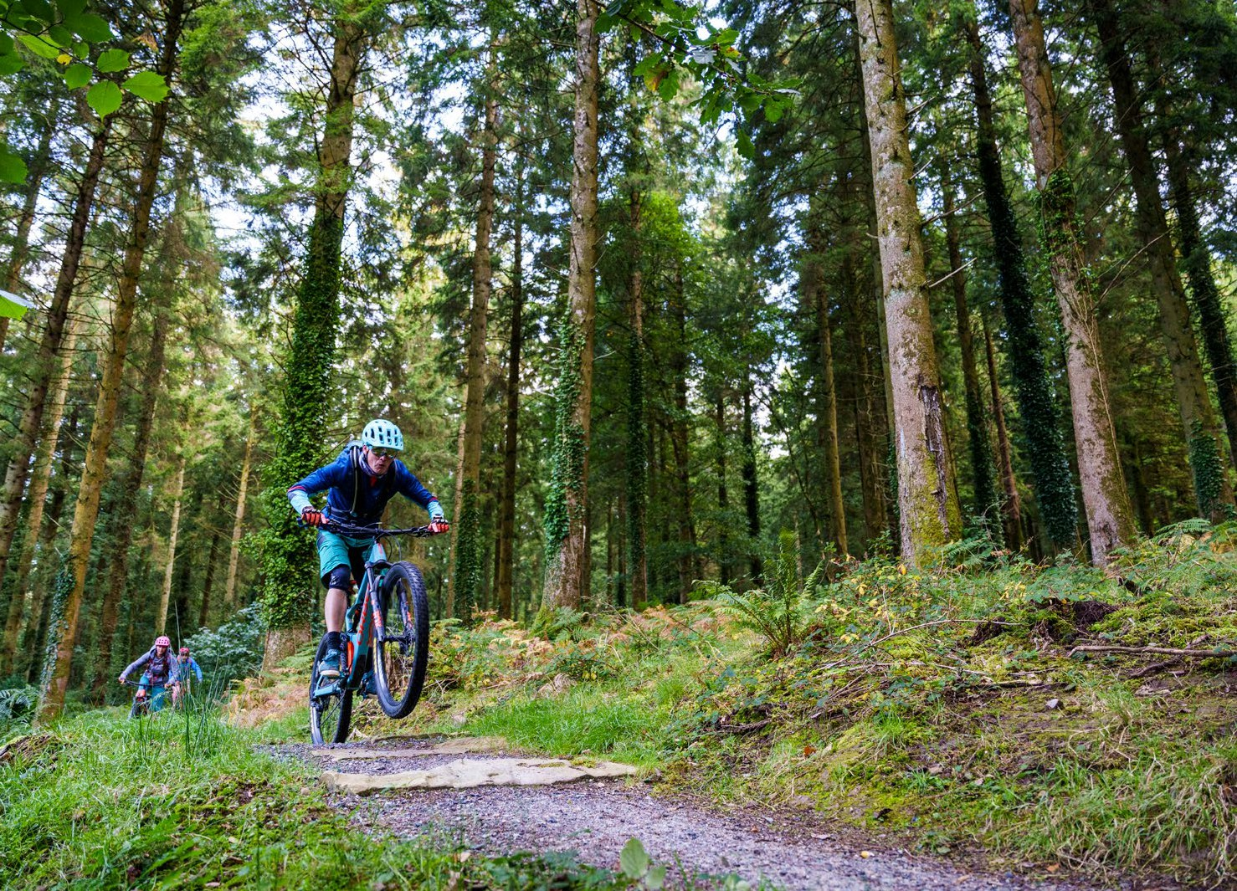

�PORT EIREANN
SPORT I
EIREAN SPORT
FAOINSPEI�
IORUETDLOAONRSD
FAOIN SPEIR

SPORT IRELAND
OUTDOORS

