APPENDIX 1(b)

Prompt Payments by Public Sector Bodies

Reporting Template pursuant to Government Decision S29296 of 2 and 8 March 2011 and 28 March 2017 by:

The Health Service Executive, the Local Authorities, State Agencies and all other Public Sector Bodies, (excluding Commercial Semi State bodies)

Parent Government Department: Department of Culture, Communications and Sport
Public Sector Body: Sport Ireland
Quarterly Period Covered: April – June 2025

Details | Number | Value  (€) | Percentage (%) of  total number of payments made
Total payments made in Quarter | 672 | 6831791.56 | 100%
Payments made within 15 days | 655 | 6764321.23 | 97%
Payments made within  16 days to 30 days | 15 | 58455.75 | 2%
Payments made in excess of  30 days that were subject to LPI and compensation costs | 0 | 0 | 0%
Payments made in excess of  30 days that were not subject to LPI and compensation costs | 2 | 9014.58 | 1%
Amount of late payment interest (LPI) paid in Quarter | N/A | 0 | N/A
Amount of compensation costs paid in Quarter | N/A | 0 | N/A

Signed: 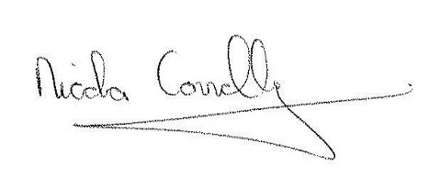

Date: 09/07/2025

