APPENDIX 1(b)

Prompt Payments by Public Sector Bodies

Reporting Template pursuant to Government Decision S29296 of 2 and 8 March 2011 and 28 March 2017 by:

The Health Service Executive, the Local Authorities, State Agencies and all other Public Sector Bodies, (excluding Commercial Semi State bodies)

Parent Government Department: Department of Tourism, Culture, Arts, Gaeltacht, Sport and Media

Public Sector Body: Sport Ireland
Quarterly Period Covered: July-Sep 2024

Details | Number | Value  (€) | Percentage (%) of  total number of payments made
Total payments made in Quarter | 623 | 4334457.93 | 100%
Payments made within 15 days | 519 | 3528228.14 | 83%
Payments made within  16 days to 30 days | 67 | 575422.58 | 11%
Payments made in excess of  30 days that were subject to LPI and compensation costs | 0 | 0 | 0%
Payments made in excess of  30 days that were not subject to LPI and compensation costs | 37 | 230807.21 | 6%
Amount of late payment interest (LPI) paid in Quarter | N/A | 0 | N/A
Amount of compensation costs paid in Quarter | N/A | 0 | N/A

Signed: 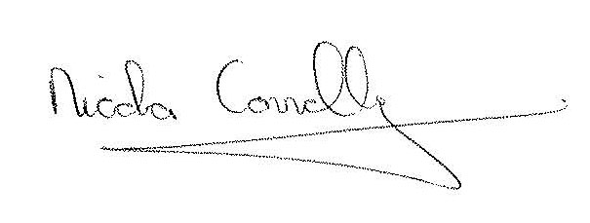

Date: 08/10/2024

