APPENDIX 1(b)

Prompt Payments by Public Sector Bodies

Reporting Template pursuant to Government Decision S29296 of 2 and 8 March 2011 and 28 March 2017 by:

The Health Service Executive, the Local Authorities, State Agencies and all other Public Sector Bodies, (excluding Commercial Semi State bodies)

Parent Government Department: Department of Tourism, Culture, Arts, Gaeltacht, Sport and Media
Public Sector Body: Sport Ireland
Quarterly Period Covered: January – March 2025

Details | Number | Value  (€) | Percentage (%) of  total number of payments made
Total payments made in Quarter | 662 | 6842795.39 | 100%
Payments made within 15 days | 627 | 5888793.52 | 94%
Payments made within  16 days to 30 days | 24 | 264340.22 | 4%
Payments made in excess of  30 days that were subject to LPI and compensation costs | 0 | 0 | 0%
Payments made in excess of  30 days that were not subject to LPI and compensation costs | 11 | 689661.65 | 2%
Amount of late payment interest (LPI) paid in Quarter | N/A |  | N/A
Amount of compensation costs paid in Quarter | N/A |  | N/A

Signed:
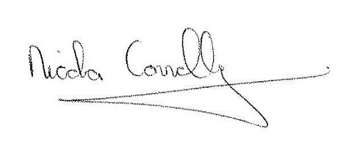
Date: 08/04/2025

