Sport Ireland Research Grant Scheme
1 - Year Project

2025

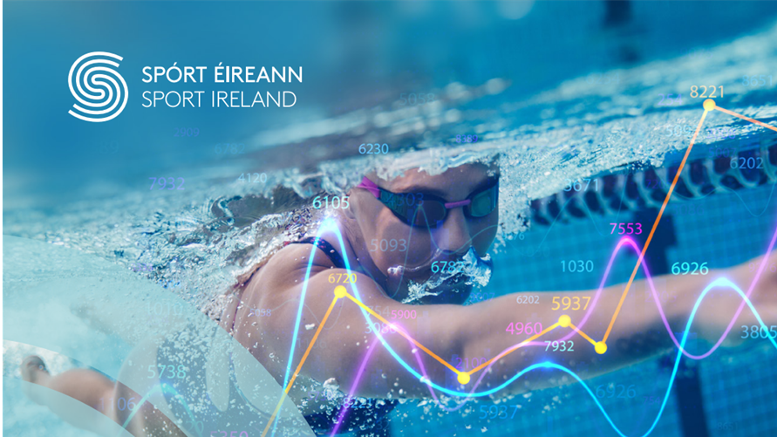

Sport Ireland Research Grant Scheme
2025 1-Year Project
Application Form

Please refer to the guidelines document to aid completion of the application form. Questions with an asterisk are required for completion. Closing date for application submissions is 5 pm on Monday, 31st March 2025. All application materials need to be submitted to research@sportireland.ie.

Section 1: Application Lead
Section 2: Project Partners
Section 3: Project Scope
Section 4: Project Methods
Section 5: Project Management
Section 6: Funding

Section 1- Application Lead

1. | Lead Organisation:
2. | Lead applicant name:
3. | Lead applicant email address:
4. | Organisation type (NGB/LSP/Other SI Funded Body):
5. | What is your title/role in the organisation?

Section 2 - Project Partners
6. Do you plan to complete the research with a partner organisation?
☐ Yes
☐ No

7. | Partner Organisation:
8. | Partner name:
9. | Partner email address:
10. | Organisation type (HEI/Other):
11. | Partner’s title/role in the organisation?

12. Are you including a letter of support or intent from a partner organisation as an attachment with your application submission?
☐ Yes
☐ No

Section 3 – Project Scope
13. What option best indicates your research area? You can pick more than one where applicable. If your research area is not included, please list under Other.
Sport Subject Areas | Target Group – if applicable
☐ Participation  ☐ High Performance*  ☐ Athlete Pathways  ☐ Coaching  ☐ Volunteering (other than coaching)  ☐ Outdoors  ☐ Governance  ☐ Technology  ☐ Psychology  ☐ Environmental Sustainability | ☐ Women In Sport  ☐ People with a Disability  ☐ LGBTQ+  ☐ Children  ☐ Older Adults  ☐ Ethnic Minorities  ☐ Socio-economic disadvantage,  ☐ Athletes  ☐ Coaches  ☐ Sport Parents / Guardians  ☐ Other:
*: If projects are marked as ‘High-Performance’, a signature of approval from the Director, Sport Ireland Institute must be obtained on the Declaration Form for grant applications which seek to invite International Carding Scheme athletes, or their support personnel, to participate in the research project.

14. Please provide a lay abstract for your proposed research that will be used to inform a non-expert audience. Max 300 words *

15. Please provide details of the central research questions and proposed aims/objectives of the research project. Max 300 words *

16. Please summarise the existing literature on this topic which has been used to inform this proposal. Max 300 words *

17. Please provide details of how the project will advance your organisation’s knowledge or support previous research undertaken in this area. Max 300 words *

Section 4 – Project Methods
18. Please give a brief description of the research design and methodologies to be employed, e.g., target population, measures being used / developed, type of intervention or comparison being made, technology being developed, number of participants, interviews, focus groups, etc. Max 300 words *

19. Please provide details on proposed data collection protocols and potential methods of analysis. Max 300 words *

20. Please provide a statement detailing the careful consideration you have given to the ethical and GDPR implications of the proposed research (e.g., informed consent, recruitment, vulnerable populations, child safeguarding, etc.). Where ethical or GDPR issues may arise please summarise how you plan to address these over the course of your research. Max 300 words *

21. Will the proposed research project be approved by an Institutional Review Board or HEI Ethics Committee prior to beginning?
☐ Yes If ‘Yes’, please specify Board or Committee name: _____________________________
☐ No
Section 5 – Project Management
22. Please outline relevant professional and/or academic experience of the applicant and partners. Max 300 words *

23. Please provide a project timeline and details on milestones / deliverables and associated dates for each phase of the proposed research. Max 300 words *

24. Please identify potential risks that might impact successful completion of the project. Max 300 words *

25. Please describe how an effective working collaboration/partnership across team members will be sustained over the course of the project (resource/expertise sharing, team meetings, data access, delegation of roles and responsibilities, etc.). Max 300 words *

26. Please outline your plans for the dissemination of your research, including publications, media coverage, conference attendance, workshops, toolkits and any other outreach activities. Max 300 words *

Section 6 - Funding
**The maximum project funding is up to €18,000 Euro. Please note funding must be expended by the end of August 2026**
27. How much funding are you requesting? *

28. If the lead applicant or partner organisation are providing matched funding, please list the provider and amount.

29. Please give a breakdown of proposed project expenditure. If receiving matched funding from other sources, please include this in your expenditure total. *

Section 5- Signed Declaration
22. Have you completed a signed Declaration Form as part of your application submission? *
☐ Yes
☐ No

Please email your completed application materials to research@sportireland.ie

Application Checklist
Have you included:
1. Sport Ireland Research Grant Scheme Application Form (required)
2. Signed Declaration Form (required)
3. Letter of support or intent from a partner organisation (optional)

