APPENDIX 1(b)

Prompt Payments by Public Sector Bodies

Reporting Template pursuant to Government Decision S29296 of 2 and 8 March 2011 and 28 March 2017 by:

The Health Service Executive, the Local Authorities, State Agencies and all other Public Sector Bodies, (excluding Commercial Semi State bodies)

Parent Government Department: Department of Tourism, Culture, Arts, Gaeltacht, Sport and Media

Public Sector Body: Sport Ireland
Quarterly Period Covered: Jan 2024 – March 2024
Details | Number | Value | Percentage (%) of
 |  | (€) | total number of payments made
Total payments made in Quarter | 603 | 6122069 | 100%
Payments made within 15 days | 448 | 3080817 | 74%
Payments made within | 124 | 1946098 | 21%
16 days to 30 days
Payments made in excess of | 0 | 0 | 0%
30 days that were subject to LPI and compensation costs
Payments made in excess of | 31 | 1095154 | 5%
30 days that were not subject to LPI and compensation costs
Amount of late payment interest (LPI) paid in Quarter | N/A | 0 | N/A
Amount of compensation costs paid in Quarter | N/A | 0 | N/A

Signed: 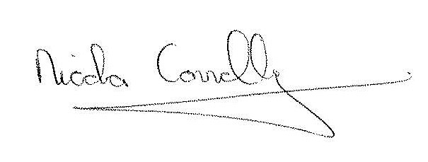

Date: 10/04/2024

