APPENDIX 1(b)

Prompt Payments by Public Sector Bodies

Reporting Template pursuant to Government Decision S29296 of 2 and 8 March 2011 and 28 March 2017 by:

The Health Service Executive, the Local Authorities, State Agencies and all other Public Sector Bodies, (excluding Commercial Semi State bodies)

Parent Government Department: Department of Tourism, Culture, Arts, Gaeltacht, Sport and Media

Public Sector Body: Sport Ireland
Quarterly Period Covered: Oct 2023 – Dec 2023

Details | Number | Value  (€) | Percentage (%) of  total number of payments made
Total payments made in Quarter | 725 | 9718632.24 | 100%
Payments made within 15 days | 584 | 8730149.26 | 80%
Payments made within  16 days to 30 days | 120 | 615974.42 | 17%
Payments made in excess of  30 days that were subject to LPI and compensation costs | 0 | 0 | 0%
Payments made in excess of  30 days that were not subject to LPI and compensation costs | 21 | 372508.56 | 3%
Amount of late payment interest (LPI) paid in Quarter | N/A | 0 | N/A
Amount of compensation costs paid in Quarter | N/A | 0 | N/A

Signed: 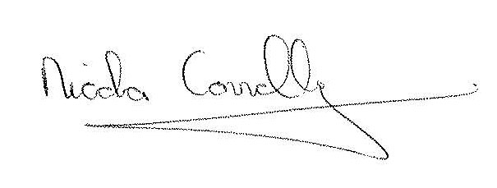

Date: 10/01/2023

