APPENDIX 1(b)

Prompt Payments by Public Sector Bodies

Reporting Template pursuant to Government Decision S29296 of 2 and 8 March 2011 and 28 March 2017 by:

The Health Service Executive, the Local Authorities, State Agencies and all other Public Sector Bodies, (excluding Commercial Semi State bodies)

Parent Government Department: Department of Tourism, Culture, Arts, Gaeltacht, Sport and Media

Public Sector Body: Sport Ireland
Quarterly Period Covered: July – Sep 2023

Details | Number | Value  (€) | Percentage (%) of  total number of payments made
Total payments made in Quarter | 590 | 4447004 | 100%
Payments made within 15 days | 558 | 3293396 | 94%
Payments made within  16 days to 30 days | 27 | 1138206 | 5%
Payments made in excess of  30 days that were subject to LPI and compensation costs | 0 | 0 | 0
Payments made in excess of  30 days that were not subject to LPI and compensation costs | 5 | 15402 | 1%
Amount of late payment interest (LPI) paid in Quarter | N/A |  | N/A
Amount of compensation costs paid in Quarter | N/A |  | N/A

Signed: 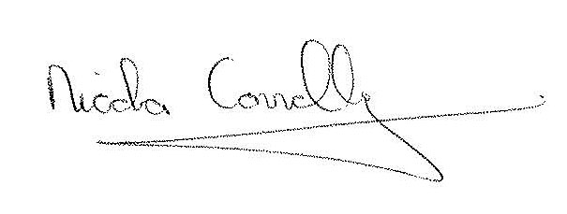

Date: 12/10/2023

