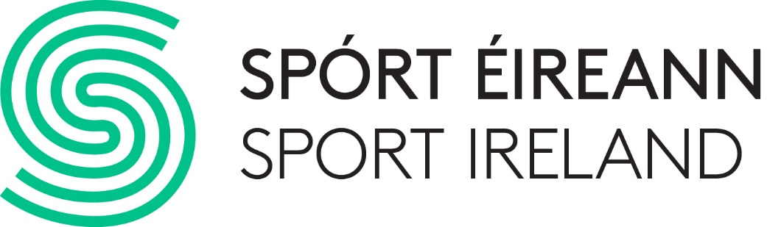

Analysis and Punditry Training Programme Application Form

Please complete the below application form to apply for the Sport Ireland Women in Sport Analysis and Punditry Training Programme.
Your application must be accompanied by a brief personal statement and a short video or audio clip.
Personal Statement:
The personal statement should give a summary of why you are interested in partaking in this programme, and how your experience makes you a suitable candidate for the programme. The personal statement should not exceed 600 words.
Audio or Video Clip:
Candidates are also asked to submit a short video or audio clip to support their application. This clip should provide a sample of the candidate analysing a passage of play from a match or event. There is no minimum limit on the length of audio/video to be submitted. The maximum length is 3 minutes. This clip can be created specifically by the individual or a prior recording from a match/event/show they contributed to.
Data Protection:
Sport Ireland is aware of its obligations under Data Protection law. The application form and the information below should be read in conjunction with our privacy policy: www.sportireland.ie/privacy-policy
- The information collected will only be used for assessing and communicating with applicants
- It won’t be shared with any third parties
- It will be securely deleted once the assessment process is concluded

Application form:

Name:
Email:
Phone:
Sport (s)
(please only include those you are most knowledgeable in)
Summary of Playing Experience

Summary of Previous Media Experience
(if any):

Link to Sample Video/Audio
(if necessary)
Sample Video/Audio | Yes ☐ No ☐
Confirm availability for training dates.  Candidates who miss days may be forced to drop out of the programme. | Candidates will be split into two groups for the duration of the training. Please tick the dates below to confirm your availability.  Group 1  Day 1 - June 18th ☐  Day 2 - June 25th ☐  Day 3 - July 2nd ☐  Group 2  Day 1 - July 9th ☐  Day 2 - July 16th ☐  Day 3 - July 25th ☐
Personal Statement (Max 600 words):

The closing date for applications is midnight on Friday, 27th May 2022. No late applications will be considered.
A panel that includes representations from the media sector, the training provider and Sport Ireland will assess applications.
If you require further information, please contact womeninsportproject@sportireland.ie

