

**Risk Management Policy**

Sample Draft

**Governance Code for Sport**

Disclaimer

Sport Ireland is making available a range of resources including guidance notes, policy documents and templates for selected areas aligned to the Governance Code for Sport which will support sport organisations, boards, management and staff in the development of relevant governance processes and procedures particular to their own organisation.

For the avoidance of doubt, the final decision on the nature, type, extent and format of approved governance policies, procedures and processes for each organisation is a matter for the board / highest governing structure of the organisation and the resources and material provided may assist the approval process.

This document is not, nor is it intended to be, a definitive statement of the law and it does not constitute legal advice. This document is not a substitute for professional advice from an appropriately qualified source and it is recommended that sport organisations consult their governing document or obtain their own independent legal advice where necessary.

Sport Ireland does not accept any responsibility or liability for any errors, inaccuracies or omissions in this document.

How to Use this Document

Proportionality is a key aspect of the Governance Code for Sport and this is recognised in the sample policy below which provides two options:

Option 1 will provide a strong basis for a Type A and Type B organisation in the area of Risk Management. It is recognised that volunteer led organisations or organisations with a smaller number of employees will have a different risk profile and risk management approach than larger organisations in the sports sector.

Option 2 is a more detailed and comprehensive policy. This option is likely of most relevance to Type C organisations. However it could be used by other organisations seeking to embed a more detailed and comprehensive approach to Risk Management within their organisations

In all cases the policy will require some adjusting to reflect the staffing arrangements, organisational structure or Board structure. There are various template options provided in the Appendix for Risk Registers the policy and template risk registers will require reflection and adjustment dependent on the structure and risk profile of the organisation.

Version: V1.0

Date: DD/MM/YYYY

Version Control History:

|  |  |  |
| --- | --- | --- |
| TOR XXX | Name of Sport Organisation – Name of specific policy | |
| Version No. | Date | Status |
|  |  |  |
|  |  |  |

Introduction

Good governance asserts that the role of the Board as (usually) the governing body or board of directors, (there could be specific alternative arrangements in some cases) is to provide leadership and direction to the organisation within a framework of prudent and effective controls, which enables risk to be assessed and managed. The Board, management and staff are committed to the principles of good governance and to comply with relevant legal and regulatory requirements and the obligation of the Governance Code for Sport.

An effective control system provides assurance that, as an organisation, we will not be hindered in the achievement of our objectives or in the orderly and legitimate conduct of our activities by circumstances that are reasonably foreseeable. The essence of risk is uncertainty, and risk is defined in ISO 31000 as “the effect of uncertainty on objectives – the effect being positive or negative”. While we need to address and mitigate to the maximum extent possible, threats and exposures to our organisational priorities, activities and programmes, the definition of risk also requires us to consider the opportunities or upside risks that exist in the uncertain environment we operate in and how we can address and exploit these opportunities.

An effective risk management system identifies and assesses threats and opportunities and ensures that they are effectively managed. Our risk management initiatives should be integrated with other management processes to support decision making and to assist in achieving our aims, purpose and priorities.

Purpose

The purpose of this policy is to provide a framework to identify, assess and rank risks, and to develop strategies to deal with risks so as to provide reasonable assurance that the strategic objectives and priorities of the organisation will be achieved. The Risk Management Policy (RMP) sets, in effect, the framework in which risks (threats and opportunities) will be managed. As part of this overall RMP, it is expected that the Board, in conjunction with the chief executive and the executive, will develop a risk appetite statement for the organisation. The risk process will also yield a risk register to reflect current or emerging uncertainties and actions in place to address the threats and exploit the opportunities. Risk registers are” live” documents that need to be regularly reviewed and refreshed to ensure they capture current uncertainties, threats, vulnerabilities and opportunities.

This policy aims to formalise and embed the process of risk management in the culture and ethos of our organisation and provide a risk management framework to identify, assess and manage risk by developing strategies that will provide assurance that the organisations objectives will be achieved. The policy also contributes to the effective management of potential threats and opportunities and sets out the roles and responsibilities for managing risk throughout the organisation. The Policy sets out the following:

1. Definition of Terms;
2. Risk Governance Structure: Roles and Responsibilities of the Board, the Audit & Risk Committee or any Committee with responsibility for overseeing the effectiveness of the risk management framework, the Chief executive and the executive;
3. Risk Management Framework; Risk Identification and Assessment, Risk Treatment, Risk Monitoring and Reporting, Risk Register, Risk Appetite and Risk Escalation.
4. Definition of Terms
5. Risk

Risk is defined as the effect of uncertainty on objectives, and the effects can be positive and / or negative. Risk may be considered as uncertainties that could result in the organisation suffering loss, damage or disadvantage, not benefiting from opportunities available or not achieving its objectives due to unwanted or uncertain internal or external events or actions. Risks, by their very nature, may or may not occur and from our organisational perspective, they could be categorised as strategic, reputational, stakeholder, financial, technological, personnel/ talent, operational etc.

1. Risk Management

Risk management is the on-going process effected by the Board, committees, chief executive and staff to identify, assess, manage and control potential events or situations in order to provide reasonable assurance regarding the achievement of objectives and to drive value in the organisation. The organisation endeavours to manage all risks to be within its risk appetite and which could prevent the attainment of our stated objectives, purpose or aim while at the same time not limiting its ability to attain those same objectives by taking on an acceptable level of risks which may lead to positive outcomes and add value.

It is recognised that risk management is not solely about managing risks, it is about identifying and taking opportunities. It is also acknowledged that risk management is about being ‘risk aware’ rather than ‘risk averse’. The intention is that risk management will become embedded in the culture within the organisation rather than operate as a standalone function. As potential risks often outweigh the resources available to manage them, it is therefore important to apply available resources to mitigate risks in a cost-effective and efficient manner.

1. Risk Assessment

This is the process to determine the likelihood/ probability of specific events occurring and the magnitude of their possible consequence/impact on the organisation. Risks are assessed and prioritised on the combined basis of their likelihood of occurrence and the resulting impact should they materialise using a ranking scale.

1. Risk Register

The risk register is a recording and monitoring tool. The Corporate Risk Register is a key governance document for the Board and the Audit and Risk Committee and it will be informed by the operational and strategic activities, and by the internal and external environment within the organisation.

1. Risk Appetite

A Risk Appetite Statement specifies the amount of risk the organisation is willing to seek, pursue, accept or tolerate in the pursuit of our mission, our purpose, our aims and the long -term objectives. It reflects the risk management philosophy, and in turn, influences the organisation’s culture and operating style. It indicates the parameters within which the organisation would want to conduct its activities.

Setting a risk appetite is not about the elimination of all risks; rather, it is about embracing risks in areas in which management has the appropriate skills, knowledge and experience to take advantage of the opportunities presented, whilst limiting risks in other areas. The approach of the organisation is to engage in reasoned and reasonable risk-taking. The priority is on minimising exposure to reputational, compliance and financial and other risks, whilst accepting and encouraging an increased degree of calculated risk taking and exploiting opportunities in pursuit of its objectives and priorities. It recognises that its appetite for risk varies according to the activity undertaken, and that its acceptance of risk is subject always to ensuring that potential benefits and risks are fully understood before developments are authorised, and that sensible measures to mitigate risk are established. A balanced assessment has to be taken on threats and opportunities. The Board and Chief executive recognise that in many cases, there are risks attached to both doing something and doing nothing.

1. Risk Governance Structure: Roles & Responsibilities

All staff have a part to play in managing risk by:

* being aware of the nature of risks in their day-to-day work;
* monitoring the effectiveness of management procedures created to mitigate those risks identified;
* being responsive to the changing nature of the risks faced by the organisation.

Specific responsibilities for policy and processes are as follows:

* **The Board**

|  |  |
| --- | --- |
| *Option 1* | The **Board** has a number of key responsibilities including to approve the risk management framework and monitor its effectiveness and review the appropriateness and implementation of risk management arrangements within the organisation. The board are supported in this area by the **Audit and Risk Committee, if such a committee exists** or any Committee with responsibility for overseeing the effectiveness of the risk management framework. |
|  |  |
| *Option 2* | The role of the Board is to provide leadership and direction within a framework of prudent and effective controls that enables risk to be assessed and managed. The Board is responsible for determining the nature and extent of the principal risks it is willing to take in achieving its strategic objectives and priorities. The Board is responsible for maintaining sound risk management and internal control systems within the organisation.  The Board, in conjunction with the chief executive and the executive, is responsible for establishing and maintaining a sound system of internal control that supports the achievement of policies, aims and objectives. The system of internal control is designed to respond to and manage the whole range of risks that the organisation faces. The Board is responsible for approving the risk management framework, and monitoring its effectiveness, regularly reviewing the corporate risk register as well as approving the risk appetite statement. It is supported in this work by the Audit and Risk Committee (ARC). In addition, the Board, through its Committee[1], shall require an external review of the effectiveness of the Risk Management Framework and its governance periodically.  Other key elements of the Board’s oversight of risk management include:   * making risk management a standing item on the Board meeting agenda * reviewing management reporting on risk management and noting/approving actions as appropriate * ensuring risk management experience/expertise in the competencies of at least one Board member. Where the composition of the Board does not allow for this, expert advice should be sought externally. * confirmation in the annual report that the Board has carried out an assessment of the principal risks, including a description of these risks, where appropriate, and associated mitigation measures or strategies. |

* **The Chief Executive**

|  |  |
| --- | --- |
| *Option 1* | The Chief Executive is responsible for ensuring that risk management is embedded in the management processes and that the key strategic risks are being addressed and managed appropriately within each directorate or unit. This includes requiring assurance from colleagues in relation to the management of risks within their area, supporting the process to Identify key strategic risks and ensuring procedures for managing risk are fully understood and implemented as part of planned programmes and key activities. |
|  |  |
| *Option 2* | The Chief executive (or the most senior position/Board if the CEO doesn’t exist) has overall responsibility for ensuring that procedures and processes are in place to enable adherence to this Risk Management Policy. Additionally, he/she will:   * Ensure the implementation of the Risk Management Policy across the organisation * Encourage a risk management culture throughout the organisation so that risk awareness is embedded as part of the organisation’s decision making and operations * Identify and monitor corporate level risks that could impact on the achievement of the strategic objectives and outline to ARC / Board where a new corporate level risk arises or where there are significant changes in circumstances surrounding an existing one * Manage the implementation of all aspects of the risk function, including the implementation of processes, tools and systems to identify, assess, measure, manage, monitor and report risks. |

* **The Chief Risk Officer / Executive Lead on Risk / Risk owner (ideally this should be a different position.**

The Chief Risk Officer / Executive Lead on Risk/Risk Owner is responsible for

* Supporting the implementation of all aspects of the risk function, including the implementation of processes, tools and systems to identify, assess, measure, manage, monitor and report risks.
* Assist in the development of and management of processes to identify and evaluate business areas' risks
* Co-ordinate the corporate risk reporting and review process and manage and maintain infrastructure elements (e.g. management reporting, including reporting to committees).
* Ensure the provision of adequate training and awareness of risk management
* Ensure the communication of the key elements of the Risk Management Framework
* Report to the Audit & Risk Committee/Board on the Corporate Risk Register and the implementation of the Risk Management Framework.
* **Executive Staff**

Individual executive staff members have a key part to play in managing risk by:

* being aware of the nature of risks in their day-to-day work as well as being aware of risks within the corporate risk register;
* monitoring the effectiveness of management procedures created to mitigate those risks identified;
* being responsive to the changing nature of the threats and opportunities faced by the organisation;
* proactively identifying and mitigating, where possible, significant risks and bringing these to the attention of colleagues.
* Managing risk effectively within their own work and area of authority
* Escalation of risk events or “near miss” incidents when they occur
* Supporting the Chief executive and chief risk officer / executive lead on risk in the implementation of the Risk Management Policy.

1. Risk Management Framework

Risk Management is an iterative process consisting of steps which, when taken in sequence, enable continual improvement in risk management and decision making. It constitutes a logical and systematic method of identifying, analysing, evaluating, treating, monitoring and communicating risks associated with any activity, function or process in a way that will enable the organisation to minimise losses and maximise opportunities.

Effective risk management focuses on understanding and measuring risk rather than necessarily avoiding or totally eliminating it, and within the organisation it comprises the following components:

Figure 1: Risk Management Cycle

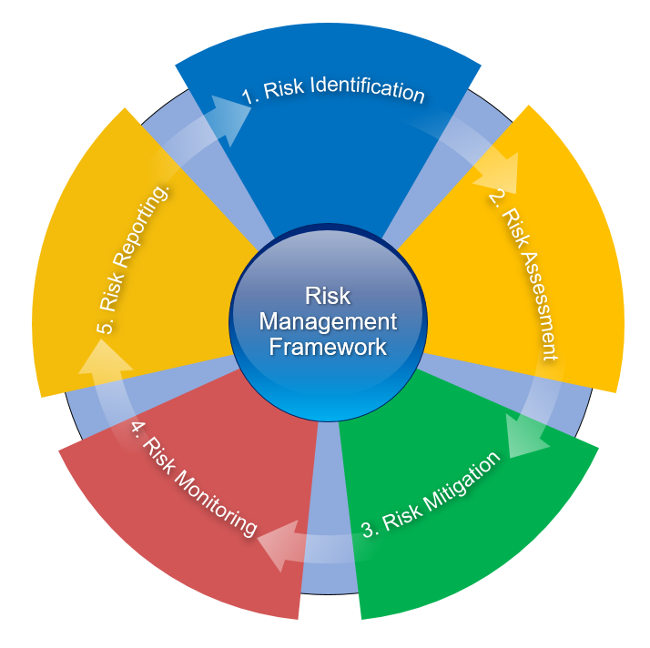

Risk management is the identification, consideration, monitoring of risks and controls that can affect performance and the achievement of our objectives. Each of these steps are discussed below.

1. Risk Identification

This is achieved by regular monitoring and assessment of risk as part of the planning process and dealing with one-off or new uncertainties as they emerge.

1. Risk Assessment (address the risk, both threats and opportunities)

|  |  |
| --- | --- |
| *Option 1* | We identify and consider the risks relative to the various programmes and activities and evaluate the consequence/ impact as well as likelihood/probability of all such risks. |
|  |  |
| *Option 2* | Addressing each risk based on the assessment will incorporate a number of options distinguishing between threats and opportunities as shown below.  The options in relation to *threats* are to:   * Treat - Implement a suitable control or combination of controls to reduce (mitigate) the risk to a more acceptable level. * Tolerate - Knowingly accept the risk as it falls within the "risk appetite". In such circumstance, the risk is deemed acceptable, compared to the cost of improving controls to mitigate it. * Transfer - Transfer the risk to another organisation (e.g., through insurance or contractual arrangements with a business partner). * Terminate - Avoid the risk, i.e., do not undertake or stop the associated business activity.   The options in relation to *opportunities* are to:   * Exploit - Implement actions to allow for capitalising on the situation that presents itself. * Share – intensify analysis and feasibility assessment and seek shared views and support on follow up actions * Enhance – examine and analyse to see if the improvement is achievable and merits further work * Ignore – decide that the opportunity, for now, is not worth pursuing |
|  |  |

1. **Risk Mitigation**

When risks (threats and opportunities) have been identified, assessed and analysed and ranked as set out earlier in terms of likelihood and potential impact, we consider and where necessary develop or re-emphasise the mitigations and actions in place or proposed to address the significant risks identified.

In terms of mitigating threats, we use the treatment / toleration / transfer / termination approaches listed above.

In terms of capitalising on opportunities, there are several approaches we use, including:

* Exploitation – Active pursuit of the potential upsides.
* Share – further analysis and feasibility assessment and seek shared insights.
* Enhance – consider if the improvement is achievable and merits further work.
* Decline – agree that, although potential exists, now is not the right time or not worth pursuing at this stage.

1. Risk Monitoring

|  |  |
| --- | --- |
| *Option 1* | It will be the role of the accountable and responsible person (CEO/CRO) and/or the individual manager and staff to regularly review progress on risk management. |
|  |  |
| *Option 2* | There should be an on-going review and scanning of the environment in relation to threats and opportunities, and this will enable updating of the risk register regularly.  The Chief executive will submit a revised Corporate Risk Register to the Audit & Risk Committee four times a year, and to Board at least twice a year.  The annual report will include confirmation that the Board has carried out an appropriate assessment of the organisation’s principal risks, including a description of these risks, where appropriate and associated mitigation measures or strategies. |
|  |  |

1. Risk (Register) Reporting

|  |  |
| --- | --- |
| *Option 1* | The Risk Register records details of all the risks identified, their grading in terms of likelihood of occurring and seriousness of impact on the objectives of the organisation. This Register should be maintained and reviewed on an ongoing basis, and it will reflect the exposure and vulnerabilities relative to the significant risks and the prioritised mitigating actions to address same. We maintain an up-to-date risk register as a basis for implementing, monitoring and reporting the risk management activities. This is reviewed regularly by the Board and is also considered to coincide with the review of programme and activities within the annual plan. |
|  |  |
| *Option 2* | The Register is the primary tool for risk tracking, containing the overall statement of risks and the status of any risk mitigation actions. The Register should be reviewed by the Board on an ongoing basis.  The corporate risk register will include:   * a description of the risks relative to its strategic priorities and functions; * the category or type of risks; * the current mitigations and actions in place to address the risks; * an assessment of the likelihood that a risk will occur and the possible consequences if it does occur ranked in accordance with the agreed rating scale; * an outline of additional proposed mitigation actions, where appropriate; and * who is accountable and responsible for managing that risk. |
|  |  |

Within the context of risk reporting considerations should be given for **Risk Escalation**. It is recognised that risks can evolve quickly due to changes in the external environment, the proximity of an event or a change in risk appetite. Risk Escalation**, and the provision which supports risk escalation,** allows for the appropriate management of both existing and emergent risks. **The following considerations influence whether a risk may require escalation:**

* Where risks are rated as high or are judged to be a prevalent issue, these should be considered in the context of the risk appetite statement tolerances.
* Where the impact of a risk is rated major or severe using the risk matrix and the existing controls are deemed insufficient
* Where the risk trend and the external environment merit heightened monitoring of the situation
* Where the impact of a risk is major or severe in an area where the organisation has a low-risk appetite
* Where the risk relates to a substantial project or significant new programme
* The proximity of a potential risk incident

It is vital that risks are escalated in a timely manner where possible to ensure they can be managed effectively.

Review

This policy will be reviewed by the ARC (any Committee with responsibility for overseeing the effectiveness of the risk management framework) and Board on an annual basis to ensure it remains fit for purpose, and any amendments will be formally approved by Board.

Assurance

The risk management policy, the implementation of the system outlined, and the regular review of the risk register are a key part of the assurance arrangements within the organisation.

Further Reading / Additional Resources

This should be in read in conjunction with the discussion paper on Risk Appetite available on the Sport Ireland website.

Appendix 1: Risk register Templates

**Role of the Board / Governing Body**

The role of the Board / Governing Body is to provide leadership and direction within a framework of prudent and effective controls which enables risk[2] to be assessed and managed. The Board is responsible for determining the nature and extent of the principal risks it is willing to take in achieving its strategic objectives and priorities. The Board sets the Risk Appetite Statement and is responsible for maintaining sound risk management and internal control systems within the organisation.

**Risk Management Policy**

The purpose of this policy is to provide a framework to identify, assess and rank risks, and to develop strategies to deal with risks so as to provide reasonable assurance that the strategic objectives and priorities will be achieved. The Risk Management Policy (RMP) sets, in effect, the framework in which risks (threats and opportunities) will be managed.

**Risk Register**

As part of embedding risk management across the organisation,the risk process is supported by a risk register which should reflect current or emerging uncertainties and actions in place to address the threats and exploit the opportunities. Risk registers are ”live” documents that need to be regularly reviewed and refreshed to ensure they capture current uncertainties, threats, vulnerabilities and opportunities.

The Risk Register is a key governance document and it will be informed by the operational and strategic activities and by the internal and external environment within the organisation operates. Note that the sample risk register is a basic document and should be adapted for each organisation.

In the context of two illustrative priorities, Governance and Communications, this document reflects an initial consideration of threats and opportunities, the mitigating measures and actions in place.

For this example, in assessing the levels of risk the likelihood and impact of the risk is quantified. A grading of 1-5 are awarded (1 being the least likely/lowest impact, 5 being the most likely/highest impact). This table reflects the guidance in ISO 31000, the risk management standard. The risk score is calculated by multiplying both scores (the likelihood score and the consequence score) to get the total score.

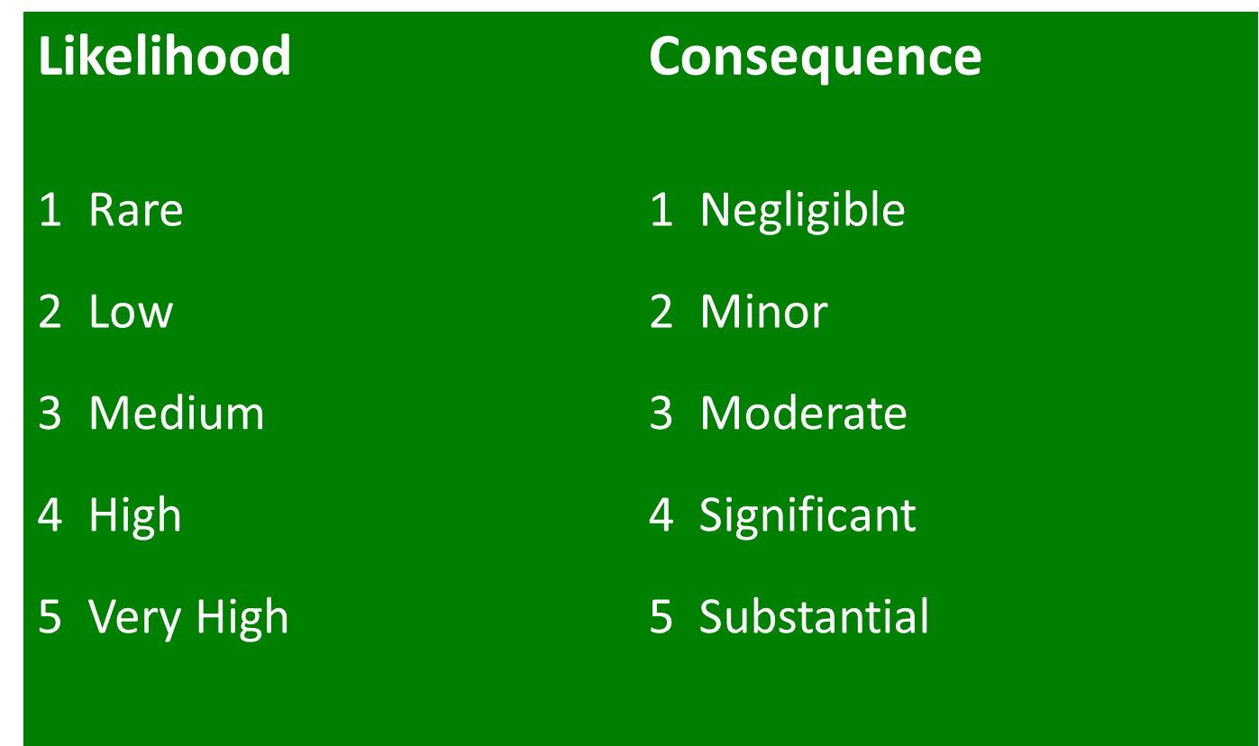

It is recognised that risk management is not solely about managing risks, it is also about identifying and taking opportunities. It is also recognised that risk management is about being ‘risk aware’ rather than ‘risk averse’.

Here below are some sample risk registers to consider, with example risks and suggested actions given.

**Priority 1 - Governance** – We are committed to enhance current and implement new good practice governance structures and arrangements across the organisation.

**Table 1: Example Risk Register (for Priority 1 - Governance)**

|  |  |  |  |  |  |  |
| --- | --- | --- | --- | --- | --- | --- |
| **Risk / Threat Descriptor** | **Current actions, mitigations or controls in place** | **Consequence** | **Likelihood** | **Score** | **Suggested actions** | **Ownership Accountability** |
| In the context of the proposed revision of our rules / governance framework/ constitution which support necessary governance changes to structures and arrangements, failure to get the necessary support and buy-in to secure the changes in governance | In order to meet the compliance requirements of the Governance Code for Sport, detailed work planned and underway to examine, update and propose necessary changes | 5 | 3 | 15 | Carry out or complete a benchmark review and consider use of Sport Ireland governance resources. Undertake actions aimed at getting buy-in, including communications around the need for changes in governance. | To be assigned |
| Current policies, procedures and protocols not fit for purpose and related failure to update governance systems or approve and implement new policies | The adoption of changes necessary were agreed at last board meeting with key action being the establishment of the governance working group/ committee who are overseeing, on behalf of Board, the development of a new Governance Framework and updates on rules | 5 | 3 | 15 | Governance working group/ committee terms of reference to be circulated and invitations to the membership to contribute to the work of the group could be considered or the use of membership focus groups as an alternative | To be assigned |
| Lack of clarity on roles and responsibilities within the governance structures and blurring of accountability and performance obligations | Work underway updating and refreshing of the schedule of matters reserved for the board to include obligations in the rules/ constitution and the governance code for sport | 5 | 4 | 20 | Board review of the terms of reference and work programmes for the board itself and the committees | To be assigned |

**Table 2: Example Opportunity Register (for Priority 1 - Governance)**

|  |  |  |
| --- | --- | --- |
| **GOVERNANCE -- OPPORTUNITY DESCRIPTOR** | | **CURRENT ACTIONS TO EXPLOIT AND DELIVER THIS OPPORTUNITY** |
| The adoption and embedding of new modern governance structures and arrangements and other initiatives can further enhance the reputation and standing of our organisation | As well as work programme, a new communications plan is being agreed and new governance section/ updates on website to show the work being done  Governance Compliance Statement to be signed off by board following due diligence approach | |
| The governance agenda will require significant and targeted investment to build capacity, capability and competencies within the membership through targeted leadership and development programmes and structured initiatives | We will avail of training and development opportunities for board and committee members and staff available from Sport Ireland  We will also scope out additional support necessary and look to resource these. | |

**Priority 2 - Communications** – Ensure an effective communications strategy, underpinned by an implementation plan, to sustain and enhance the image and profile of the organisation

**Table 3: Example Risk Register (for Priority 2 - Communications)**

|  |  |  |  |  |  |  |
| --- | --- | --- | --- | --- | --- | --- |
| **Risk / Threat Descriptor** | **Current actions, mitigations or controls in place** | **Consequence** | **likelihood** | **Score** | **Suggested Actions** | **Ownership Accountability** |
| In the context of the current and prospective membership demographic, failure to embrace and achieve benefit from new communications channels and platforms or to ensure the channels and platforms are fit for purpose | Communications strategy in development and other aspects being considered by the board  Specialist expertise recruited to assist | 5 | 4 | 20 |  | To be assigned |
| Failure to maximise the benefit of social media and other channels or platforms to communicate with members and others | Social media policy in place, Communications officer role. Aspects also within the communications strategy | 4 | 4 | 16 |  | To be assigned |

**Table 4: Example Opportunity Register (for Priority 2 - Communications)**

|  |  |  |
| --- | --- | --- |
| **COMMUNICATIONS - OPPORTUNITY DESCRIPTOR** | | **CURRENT ACTIONS TO EXPLOIT AND DELIVER THIS OPPORTUNITY** |
| The potential of the website and related technologies to host and deliver webinars, videos, blogs, etc and also to have the site reconfigured and made smartphone enabled or more accessible through other devices. | Review of functionality of website underway and looking to build on the positive and well received initiatives undertaken during Covid lockdowns | |

The example below shows a risk register mitigating measures and actions in place and a residual risk score. The residual risk score depicts the impact of controls and can be a useful tool for Boards in their risk management process. The controls to be implemented can be future actions to further control the risk response.

**Table 5: Example Risk Register with residual risk score**

| Risk Identification | | | Initial Risk Rating (Inherent) | | | Existing Control Measures | Residual Risk Rating | | | Risk Response | Controls to be Implemented | Target Implementation |
| --- | --- | --- | --- | --- | --- | --- | --- | --- | --- | --- | --- | --- |
| Risk ID | Risk Description | Strategic Objective | Risk Likelihood | Risk Impact | Risk Score | E.g. SOPs, Policies etc.. | Risk Likelihood | Risk Impact | Risk Score | Risk Owner |  |  |
| 1 |  | 1 | Possible (3) | Major (4) | 12 |  | Possible (3) | Moderate (3) | 9 |  |  |  |
| 2 | . | 3 | Remote (1) | Major  (4) | 4 |  | Remote (1) | Major  (4) | 4 |  |  |  |
| 3 |  | 3 | Unlikely (2) | Major  (4) | 8 |  | Unlikely (2) | Major  (4) | 8 |  |  |  |
| 4 |  | 3 | Possible (3) | Major  (4) | 12 |  | Possible (3) | Major  (4) | 12 |  |  |  |
| 5 |  | 3 and 4 | Possible (3) | Major  (4) | 12 |  | Unlikely (2) | Major  (4) | 8 |  |  |  |
| 6 |  | 5 | Likely (4) | Major  (4) | 16 |  | Likely (4) | Major  (4) | 16 |  |  |  |
| 7 |  | 5 | Possible (3) | Major  (4) | 12 |  | Unlikely (2) | Major  (4) | 8 |  |  | . |
| 8 |  | 5 | Almost certain (5) | Major  (4) | 20 |  | Unlikely (2) | Major  (4) | 8 |  |  |  |

**Fig 1: Example Scoring Matrix**

|  |  |  |  |  |  |
| --- | --- | --- | --- | --- | --- |
|  | Negligible (1) | Minor  (2) | Moderate (3) | Major  (4) | Extreme (5) |
| Almost certain (5) | 5 | 10 | 15 | 20 | 25 |
| Likely (4) | 4 | 8 | 12 | 16 | 20 |
| Possible (3) | 3 | 6 | 9 | 12 | 15 |
| Unlikely (2) | 2 | 4 | 6 | 8 | 10 |
| Remote (1) | 1 | 2 | 3 | 4 | 5 |

|  |  |  |  |  |  |
| --- | --- | --- | --- | --- | --- |
| **Risk No.** | **Type –**  **Corporate/Section** | **Principal Risk** | **Mitigations / Controls** | **Approx. Overall Risk Rating (H / M / L)** | **Owner** |
| 1 | Corporate |  |  |  |  |
| 2 | Corporate |  |  |  |  |
| 3 | Corporate |  |  |  |  |
| 4 | Corporate |  |  |  |  |
| 5 | Corporate |  |  |  |  |
| 6 | Xyz Section (edit) |  |  |  |  |
|  | | | | | |
| **Opp. No.** | **Type –**  **Corporate/Section** | **Principal Opportunity** | **Enablers** | **Approx. Overall Opp. Rating (H / M / L)** | **Owner** |
| 1 | Corporate |  |  |  |  |
| 2 | Corporate |  |  |  |  |
| 3 | Corporate |  |  |  |  |
| 4 | Xyz Section (edit) |  |  |  |  |

**Table 6: Sample Risk Register**

1. While the Board has established an Audit and Risk Committee to assist with its consideration of issues relating to audit, governance and risk management, the Board maintains responsibility for and makes the final decisions on all of these areas.
2. Risk is defined as the effect of uncertainty on objectives/ priorities and the effect can be positive as well as negative