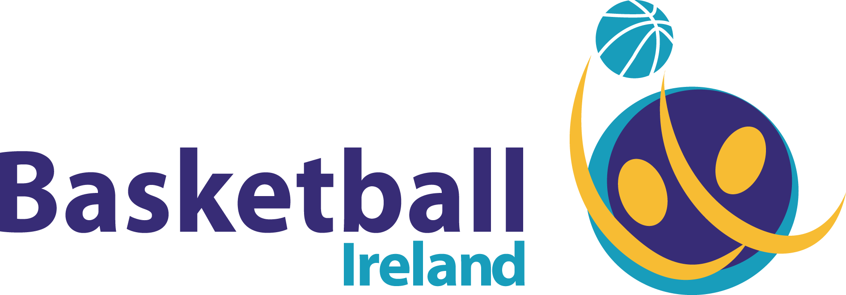

Job Vacancy: Digital Media Manager and Communications Assistant
Basketball Ireland is inviting applications for the role of Digital Media Manager and Communications Assistant
Reporting to:
Media and Communications Manager
Role Duties:
The role is to create content and maintain Basketball Ireland’s website and social channels, working closely with the Media and Communications Manager.
The Digital Media Manager and Communications Assistant will have a passion for social media and possess the ability to create dynamic content, including video.
They will assist the Media and Communications manager in all communications and media relations for Basketball Ireland, both internal and external. This will include writing previews, game reports, press releases and in-house documentation.
Dealing with both internal and external stakeholders, helping build and maintain effective working relationships.
Help create new and innovative ways to promote and market Irish basketball.
Other general media and marketing duties including, but not exclusive to, supporting live TV broadcasts and management of media, photographers, commentary and streaming.
Working as a core part of a team, to ensure the smooth running of events.
Providing support to other Basketball Ireland departments and Irish international teams.
Candidate Requirements:
At least two years experience in a similar role.
A third level qualification in Digital Media/Communications/Journalism, or relevant discipline.
Passion for social media and proven ability to create dynamic content, including video
Proficiency in use of camera equipment and ability to desktop edit, using software such as Adobe, FCP or similar.
Knowledge of content management systems, such as WordPress.
Strong communication and written skills.
Excellent interpersonal skills and experience in dealing with media contacts and the volunteer base of an organisation.
Knowledge of the sports media scene in Ireland.
Excellent organisational, scheduling and planning skills, with attention to detail
A team player and flexibility in working hours – please note there will be weekend work involved with this role.
A full, clean, driving license. The successful candidate must also have their own mode of transport for travel to and from games at weekends.
A knowledge of basketball is desired, but not essential.
PLEASE NOTE:
This is a full-time role based at Basketball Ireland headquarters at the National Basketball Arena in Tallaght, Dublin 24. The job shall start remotely, due to Covid-19.
How to Apply:
Applications for the role must include:
- Cover letter
- CV
- Links to examples of social media work or content creation
- A sample basketball game report (approx. 400 words)

All four elements of the application should be sent by email to Basketball Ireland CEO & Secretary General, Bernard O’Byrne, at bobyrne@basketballireland.ie on or before 1700 on Monday, March 22nd, 2021.

