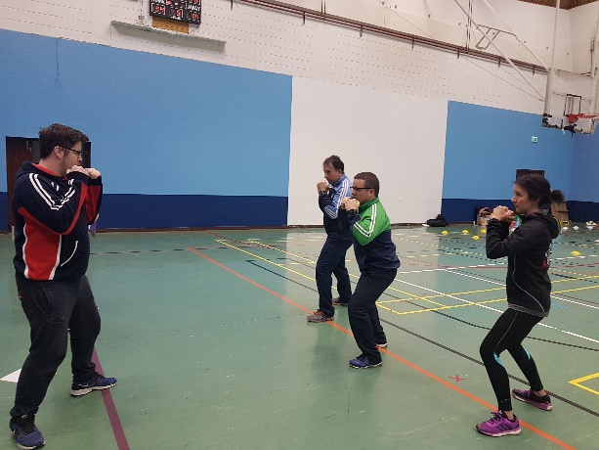

Resources for:

[COACH DEVELOPERS IN TRAINING](../OneDrive%20-%20Irish%20Sports%20Council/HAYLEY/Work%20related/SIC%20web%20page/Resources%20for%20CDs%20in%20Training)

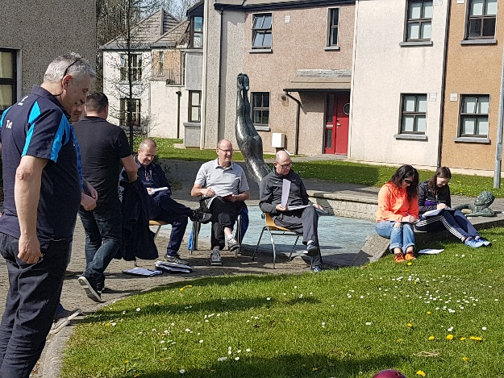

Resources for: [CDAs](../OneDrive%20-%20Irish%20Sports%20Council/HAYLEY/Work%20related/SIC%20web%20page/Resources%20for%20CDAs) (Coach Developer Assessors)

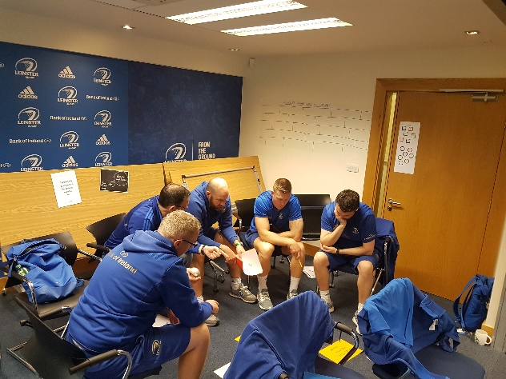

Resources for:

[NGBs](../OneDrive%20-%20Irish%20Sports%20Council/HAYLEY/Work%20related/SIC%20web%20page/Resources%20for%20NGBs) in relation to the Coach Developer Programme